**Assignment #6. JavaScript Basics (DOM Manipulation & Events)**

Student: Write your full name

Group: Write your group

**Objective:**

The goal of this assignment is to introduce the fundamentals of JavaScript, focusing on working with the Document Object Model (DOM) and event handling. By the end, students will be able to write scripts that manipulate HTML elements, respond to user interactions, and make web pages more dynamic.

**Rules for Submission:**

1. The assignment must be completed individually. If you have the same paperwork with other students, you will have 0 to this work.
2. The assignment must be submitted by the deadline which is specified in the lms.astanait.edu.kz. Works submitted after the deadline will not be accepted! To receive a grade, you must submit by deadline and defend your work at practice lesson time.
3. SUBMIT REPORT(DOC FILE) AND YOUR PROJECT FOLDER IN ZIP FORMAT. Ensure that the project runs without errors.

IN REPORT SHOULD BE:

* YOUR NAME, GROUP
* **All parts with screens(write part, task and then add screen)**
* Summary of your work process

**Part 1. Introduction to JavaScript**

**Task 0. First Script**

1. Create an HTML page and include a JavaScript file.
2. Use console.log() to print your name and group.
3. Write a script that shows an alert message: *“Hello, JavaScript World!”*.
4. console.log("JavaScript World")
5. 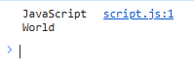
6. 

**Task 1. Variables & Operators**

1. Declare variables of different data types (string, number, boolean).
2. Perform arithmetic operations and display the results in the console.
3. Concatenate strings and print them in the console. 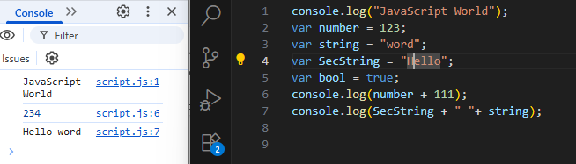

**Part 2. DOM Manipulation**

**Task 2. Changing Content**

* Create a paragraph and a button.
* When the button is clicked, change the paragraph text to something new.
* document.querySelector(".btn").addEventListener("click", function() {
* document.querySelector("p").innerHTML = "text after changing";
* });
* <h1>Changing Paragraph</h1>
* <p>My name is Dias!</p>
* <button class="btn btn-primary">change</button>
* 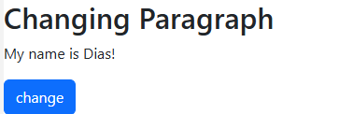Изображение выглядит как текст, Шрифт, снимок экрана, белый

  Содержимое, созданное искусственным интеллектом, может быть неверным.

**Task 3. Changing Styles**

* Create a <div> container.
* Add a button that, when clicked, changes the background color of the block.
* Add another button that changes the font size of the text inside the block.

**Task 4. Creating & Removing Elements**

* Create a button **“Add Item”** that adds a new <li> item to a list.
* Create another button **“Remove Item”** that removes the last item from the list.

**Part 3. Events**

**Task 5. Mouse Events**

* Create a box that changes color when the mouse is over it (mouseover).
* Restore the original color when the mouse leaves (mouseout).

**Task 6. Keyboard Events**

* Create an input field.
* Display the current value of the input in real time (use keyup event).

**Task 7. Form Validation (optional)**

* Create a simple form with fields: Name, Email, Password.
* Add JavaScript that prevents submission if any field is empty.
* Display an error message below the form if validation fails.

**Part 4. Mini Project — Interactive To-Do List**

**Task 8. Build a To-Do App**

* Create a text input and an **“Add Task”** button.
* When a task is added, display it in a list with a **“Delete”** button next to it.
* Add functionality to mark tasks as completed (strike-through effect).
* Store tasks temporarily in an array (no need for database/local storage).

**Evaluation Criteria (100%):**

1. **JavaScript Basics (10%)**

correct use of variables, operators, console output

1. **DOM Manipulation (10%)**

ability to change content, styles, and elements

1. **Events Handling (10%)**

correct use of mouse, keyboard, and form events

1. **Form Validation (5%)**

proper client-side validation using JS

1. **Mini Project (20%)**

working To-Do list with add/delete/complete features

1. **Design & Code Quality (5%)**

neat, readable, well-commented code

1. **Defense during Practice Lesson (30%)**

Student explains assignment clearly

Demonstrates understanding of assignment

Answers instructor’s questions correctly

Completes the given task from the instructor correctly

1. **Report (10%)**

well-structured report with all screenshots and summary

**Resources:**

1. Abitova G.A. Web technologies Front-End Development. Part 1 (2022);
2. <https://www.youtube.com/playlist?list=PLPT6CF0r4E3qOlnNkS3UXcTe7I_V8kviI>
3. <https://www.youtube.com/playlist?list=PLPT6CF0r4E3oeXhlV0N3ol5mdoOlkdH9y>
4. <https://developer.mozilla.org/enUS/docs/Web/JavaScript/Guide>
5. <https://www.w3schools.com/js/>
6. <https://javascript.info/dom-nodes>

***\*\*Questions will be based on the provided resources***

**Good luck!**

**Note:** Feel free to seek assistance from me or use online resources. You can contact me via Microsoft Teams (kuralay.makhmetova@astanait.edu.kz) or send a message on Telegram (@niholuv).

**Please remember:** contact hours are **from 9:00 AM to 9:00 PM**. Messages sent outside of this time may not receive an immediate response.